# Best Programming Practice

1. All values as variables including Fixed, User Inputs, and Results
2. Proper naming conventions for all variables
3. Proper Program Name and Class Name
4. Proper Method Name which indicates action taking inputs and providing result

**Sample Program 1:** Create a program to find the sum of all the digits of a number given by a user using an array and display the sum.

1. Use Math.random() and get a 4-digit random integer number
2. Write a method to count digits in the number
3. Write a method to return an array of digits from a given number.
4. Write a method to Find the sum of the digits of the number in the array
5. Finally, display the sum of the digits of the number

// Create SumOfDigit Class to compute the sum of 4 digits random number

class SumOfDigits {

// Get a 4 digit random number

public int get4DigitRandomNumber() {

return (int) (Math.random() * 9000) + 1000;

}

// Find the count of digits in the number

public int countDigits(int number) {

int count = 0, temp = number;

while (temp > 0) {

count++;

temp /= 10;

}

return count;

}

// Store the digits of the number in an array

public int[] getDigits(int number, int count) {

int[] digits = new int[count];

int temp = number;

for (int i = count - 1; i >= 0; i--) {

digits[i] = temp % 10;

temp /= 10;

}

return digits;

}

// Find the sum of the elements in an array

public int sumArray(int[] array) {

int sum = 0;

for (int i = 0; i < array.length; i++) {

sum += array[i];

}

return sum;

}

public static void main(String[] args) {

// Get 4 digit random integer number

SumOfDigits sumOfDigits = new SumOfDigits();

int number = sumOfDigits.get4DigitRandomNumber();

System.out.println("The Random Mumber is: " + number);

// Get the count of digits

int count = sumOfDigits.countDigits(number);

System.out.println("The count of digit is: " + count);

// Get the array of digits from the number

int[] digits = sumOfDigits.getDigits(number, count);

// Find the sum of the digits of the number

int sum = sumOfDigits.sumArray(digits);

// Display the sum of the digits of the number

System.out.println("\nSum of Digits: " + sum);

}

}

# 

# Level 3 Practice Programs

1. Create a program to find the shortest, tallest, and mean height of players present in a football team.

**Hint =>**

1. The formula to calculate the mean is: mean = sum of all elements/number of elements
2. Create an int array named heights of size 11 and get 3 digits random height in cms for each player in the range 150 cms to 250 cms
3. Write the method to Find the sum of all the elements present in the array.
4. Write the method to find the mean height of the players on the football team
5. Write the method to find the shortest height of the players on the football team
6. Write the method to find the tallest height of the players on the football team
7. Finally display the results
8. Extend or Create a ***NumberChecker*** utility class and perform following task. Call from main() method the different methods and display results. Make sure all are static methods

**Hint =>**

1. Method to Find the count of digits in the number
2. Method to Store the digits of the number in a digits array
3. Method to Check if a number is a duck number using the digits array. A duck number is a number that has a non-zero digit present in it
4. Method to check if the number is a armstrong number using the digits array. ​​Armstrong number is a number that is equal to the sum of its own digits raised to the power of the number of digits. Eg: 153 = 1^3 + 5^3 + 3^3
5. Method to find the largest and second largest elements in the digits array. Use ***Integer.MIN_VALUE*** to initialize the variable.
6. Method to find the the smallest and second smallest elements in the digits array. Use ***Integer.MAX_VALUE*** to initialize the variable.
7. Extend or Create a ***NumberChecker*** utility class and perform following task. Call from main() method the different methods and display results. Make sure all are static methods

**Hint =>**

1. Method to find the count of digits in the number and a Method to Store the digits of the number in a digits array
2. Method to find the sum of the digits of a number using the digits array
3. Method to find the sum of the squares of the digits of a number using the digits array. Use ***Math.pow()*** method
4. Method to Check if a number is a harshad number using a digits array. A number is called a Harshad number if it is divisible by the sum of its digits. For e.g. 21
5. Method to find the frequency of each digit in the number. Create a 2D array to store the frequency with digit in the first column and frequency in the second column.
6. Extend or Create a ***NumberChecker*** utility class and perform following task. Call from main() method the different methods and display results. Make sure all are static methods

**Hint =>**

1. Method to find the count of digits in the number and a Method to Store the digits of the number in a digits array
2. Method to reverse the digits array
3. Method to compare two arrays and check if they are equal
4. Method to check if a number is a palindrome using the Digits. A palindrome number is a number that remains the same when its digits are reversed.
5. Method to Check if a number is a duck number using the digits array. A duck number is a number that has a non-zero digit present in it
6. Extend or Create a ***NumberChecker*** utility class and perform following task. Call from main() method the different methods and display results. Make sure all are static methods

**Hint =>**

1. Method to Check if a number is prime number. A prime number is a number greater than 1 that has no positive divisors other than 1 and itself.
2. Method to Check if a number is a neon number. A neon number is a number where the sum of digits of the square of the number is equal to the number itself
3. Method to Check if a number is a spy number. A number is called a spy number if the sum of its digits is equal to the product of its digits
4. Method to Check if a number is an automorphic number. An automorphic number is a number whose square ends with the number itself. E.g. 5 is an automorphic number
5. Method to Check if a number is a buzz number. A buzz number is a number that is either divisible by 7 or ends with 7
6. Extend or Create a ***NumberChecker*** utility class and perform following task. Call from main() method the different methods and display results. Make sure all are static methods

**Hint =>**

1. Method to Check if a number is a perfect number. Perfect numbers are positive integers that are equal to the sum of their proper divisors
2. Method to find the number is an abundant number. A number is called an abundant number if the sum of its proper divisors is greater than the number itself
3. Method to find the number is a deficient number. A number is called a deficient number if the sum of its proper divisors is less than the number itself
4. Method to Check if a number is a strong number. A number is called a strong number if the sum of the factorial of its digits is equal to the number itself
5. Write a program to find the factors of a number and perform various tasks using the factors array

**Hint =>**

1. Method to find factors of a number and return them as an array. Note there are 2 for loops: one for the count and another for finding the factor and storing in the array
2. Method to find the greatest factor of a Number using the factors array
3. Method to find the sum of the factors using factors array and return the sum
4. Method to find the product of the factors using factors array and return the product
5. Method to find the product of the cube of the factors using the factors array. Use ***Math.pow()***
6. Write a program to generate a six-digit OTP number using Math.random() method. Validate the numbers are unique by generating the OTP number 10 times and ensuring all the 10 OTPs are not the same

**Hint =>**

1. Write a method to generate a 6-digit OTP number using Math.random()
2. Create an array to save the OTP numbers generated 10 times
3. Write a method to ensure that the OTP numbers generated are unique. If unique return true else return false
4. Create a program to display a calendar for a given month and year. The program should take the month and year as input from the user and display the calendar for that month. E.g. for 07 2005 user input, the program should display the calendar as shown below

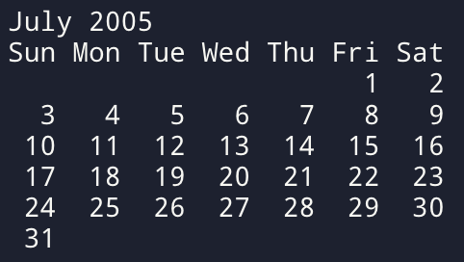

**Hint =>**

1. Write a Method to get the name of the month. For this define a month Array to store the names of the months
2. Write a Method to get the number of days in the month. For this define a days Array to store the number of days in each month. For Feb month, check for Leap Year to get the number of days. Also, define a Leap Year Method.
3. Write a method to get the first day of the month using the Gregorian calendar algorithm

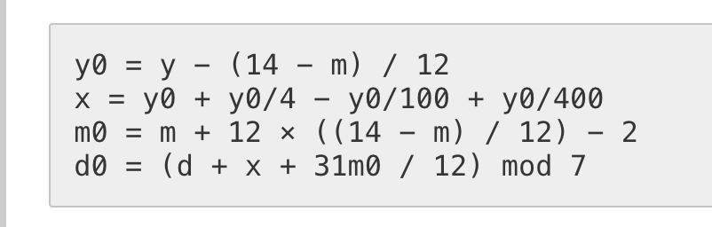

1. Displaying the Calendar requires 2 ***for*** loops.
   1. The first ***for*** loop up to the first day to get the proper indentation. As in the example above 3 spaces from Sun to Thu as to be set as July 1st starts on Fri
   2. The Second ***for*** loop displays the days of the month starting from 1 to the number of days. Add proper indentation for single-digit days using ***%3d*** to display the integer right-justified in a field of width 3. Please note to move to the next line after Sat
2. Write a program to find the 3 points that are collinear using the slope formulae and area of triangle formulae. check A (2, 4), B (4, 6) and C (6, 8) are Collinear for sampling.

**Hint =>**

1. Take inputs for 3 points x1, y1, x2, y2, and x3, y3
2. Write a Method to find the 3 points that are collinear using the slope formula. The 3 points A(x1,y1), b(x2,y2), and c(x3,y3) are collinear if the slopes formed by 3 points ab, bc, and cd are equal.

,

Points are collinear if

1. The method to find the three points is collinear using the area of the triangle formula. The Three points are collinear if the area of the triangle formed by three points is 0. The area of a triangle is

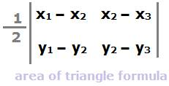

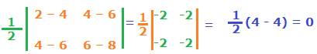

1. Create a program to find the bonus of 10 employees based on their years of service as well as the total bonus amount the 10-year-old company Zara has to pay as a bonus, along with the old and new salary.

**Hint =>**

1. Zara decides to give a bonus of 5% to employees whose year of service is more than 5 years or 2% if less than 5 years
2. Create a Method to determine the Salary and years of service and return the same. Use the ***Math.random()*** method to determine the 5-digit salary for each employee and also use the random method to determine the years of service. Define 2D Array to save the salary and years of service.
3. Write a Method to calculate the new salary and bonus based on the logic defined above and return the new 2D Array of the latest salary and bonus amount
4. Write a Method to Calculate the sum of the Old Salary, the Sum of the New Salary, and the Total Bonus Amount and display it in a Tabular Format
5. Write a program for Euclidean distance between two points as well as the equation of the line using those two points. Use Math functions ***Math.pow()*** and ***Math.sqrt()***

**Hint =>**

1. Take inputs for 2 points x1, y1, and x2, y2
2. Method to find the Euclidean distance between two points and return the distance
3. Write a Method to find the equation of a line given two points and return the equation which includes the slope and the y-intercept

The equation of a line is given by the equation where m is the slope and b is the y-intercept. So firstly compute the slope using the formulae

Post that compute the y-intercept b using the formulae

Finally, return an array having slope m and y-intercept b

1. Create a program to take input marks of students in 3 subjects: physics, chemistry, and maths. Compute the total, average, and the percentage score

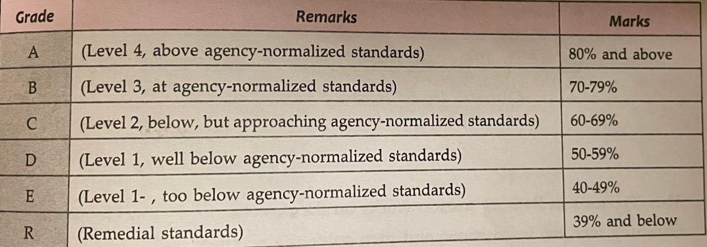

**Hint =>**

1. Take input for the number of students
2. Write a method to generate random 2-digit scores for Physics, Chemistry, and Math (PCM) for the students and return the scores. This method returns a 2D array with PCM scores for all students
3. Write a Method to calculate the total, average, and percentages for each student and return a 2D array with the corresponding values. Please ensure to round off the values to 2 Digits using the ***Math.round()*** method.
4. Finally, write a Method to display the scorecard of all students with their scores, total, average, and percentage in a tabular format using ***"\t"***.
5. Write a program to perform matrix manipulation operations like addition, subtraction, and multiplication. The program should take random matrices as input and display the result of the operations.

**Hint =>**

1. Write a Method to create a random matrix, taking rows and columns as parameters
2. Write a Method to add two matrices
3. Write a Method to subtract two matrices
4. Write a Method to multiply two matrices

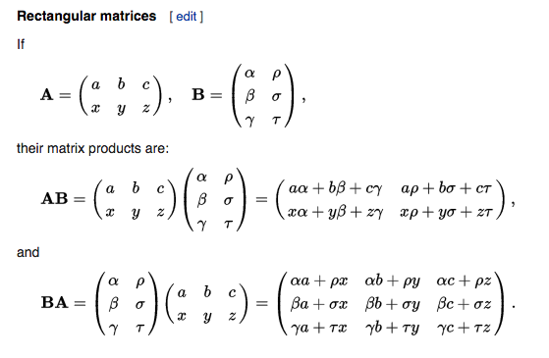

1. Write a program to perform matrix manipulation operations like finding the transpose, determinant, and inverse of a matrix. The program should take random matrices as input and display the result of the operations.

**Hint =>**

1. Write a Method to create a random matrix taking rows and columns as parameters
2. Write a Method to find the transpose of a matrix

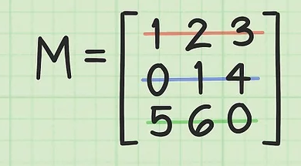 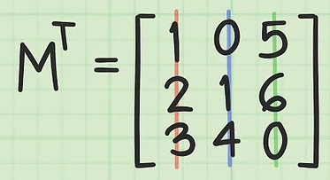

1. Write a Method to find the determinant of a 2x2 matrix



1. Write a Method to find the determinant of a 3x3 matrix

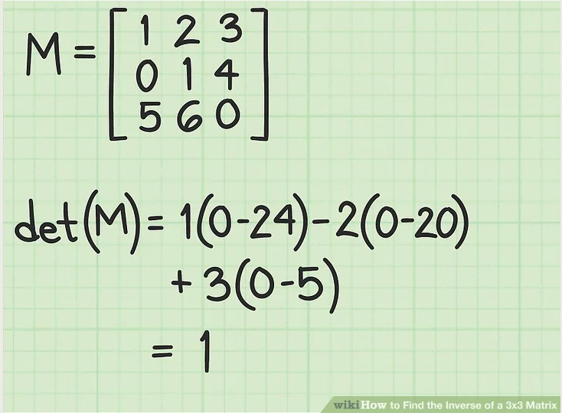 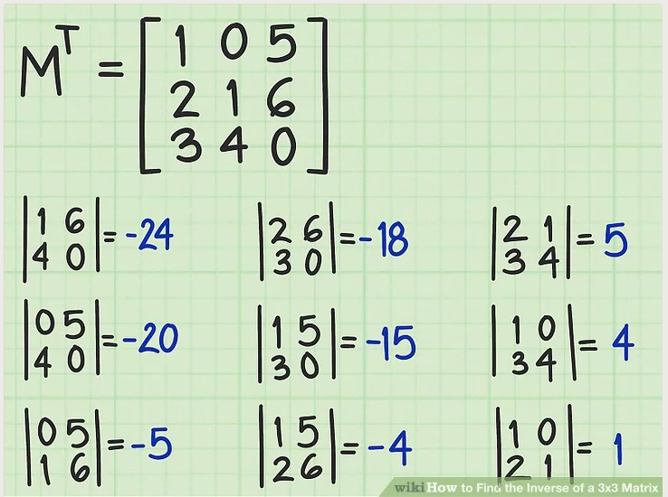

1. Write a Method to find the inverse of a 2x2 matrix
2. Write a Method to find the inverse of a 3x3 matrix
3. Write a Method to display a matrix